September 18, 2025

Subject: Call to condemn the posters targeting Illini Chabad and Rabbi Dovid

To: Chancellor Charles L. Isbell Jr., Provost John Coleman, Vice Chancellor Gioconda Guerra Pérez
University of Illinois Urbana-Champaign

Dear Chancellor Isbell, Provost Coleman, and Vice Chancellor Guerra Pérez

We draw your attention below to three examples of the many posters which were put up on and off campus last week (September 12). University of Illinois Chabad Rabbi Dovid Tiechtel was personally targeted with antisemitic language. This includes: mocking the Jewish prayer “Am Yisrael Hai” which means “the people of Israel live;” slandering the Rabbi and the Jewish institution of Chabad as supporters of ethnic cleansing; and spreading the blood libel that the Rabbi supports the murdering of non-Jewish children. These posters are a local example of a national campaign to systematically defame and render odious mainstream Jewish organizations such as the Anti-Defamation League (ADL) and Hillel as well as Chabad. The objective is to make Jews and their institutions into pariahs outside the community of the good, to make them feel hunted.

Illini Chabad hosts hundreds of our students on their premises every week. These posters make them a target. Such a horrific attack on any other minority would have been met with a swift and unequivocal response. So far, the University administration has been silent. We appeal to you in your capacity as leaders of the U of I system and ask that you condemn these posters publicly, so as to let the University community know that such hate and radicalism is not welcome on our campus. Perhaps your words may even discourage violence against the Rabbi and our Jewish students.

Signed, The FAFAA Executive Committee, on behalf of our 92 members

Brett Kaufman (co-chair), Irena Levitan, Cary Nelson (co-chair), Richard Ross, Steven Roth, Helaine Silverman, Judith White

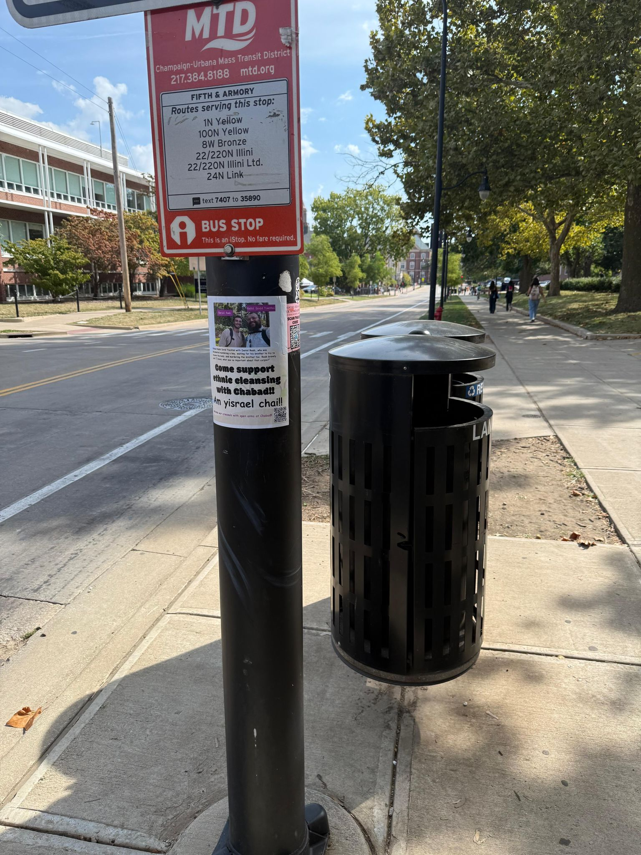
5th and Armory

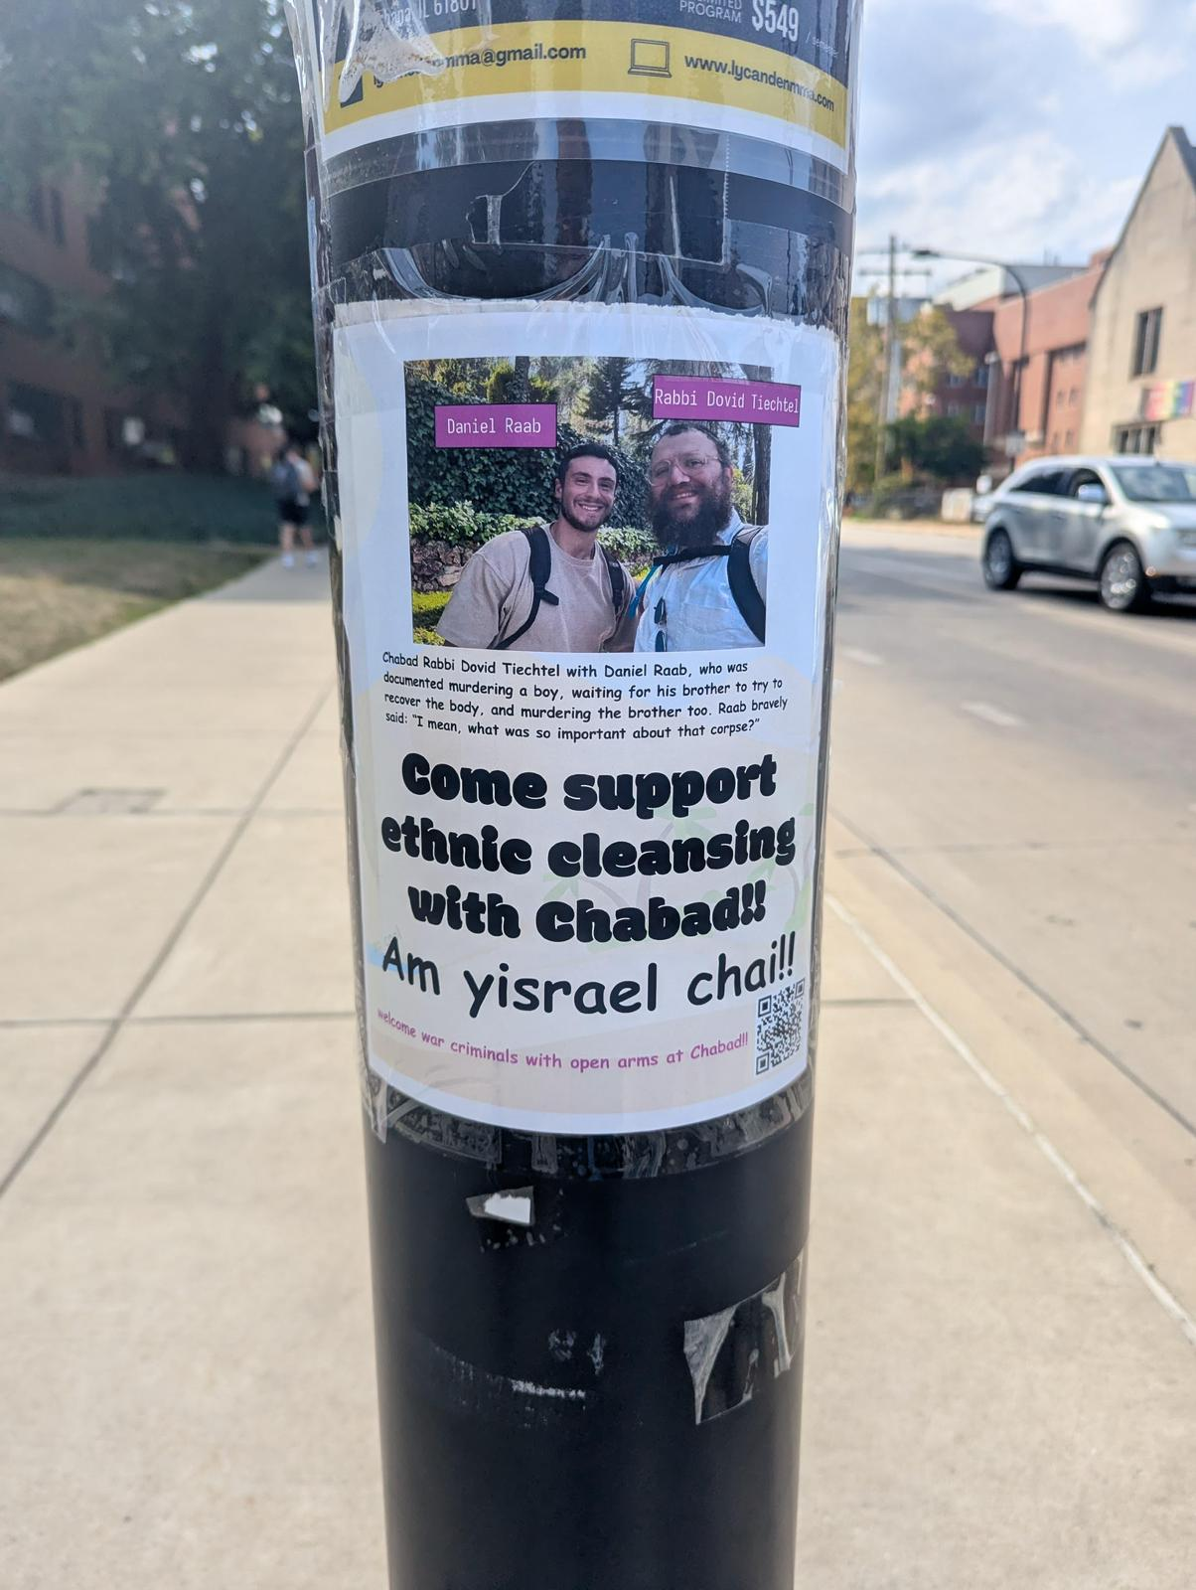
Green and S. Mathews

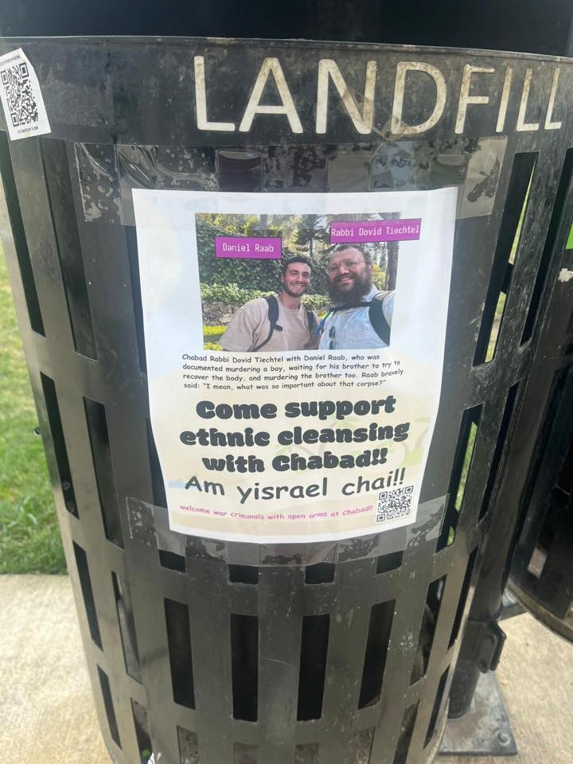
Quad

